**ER DIAGRAM:**

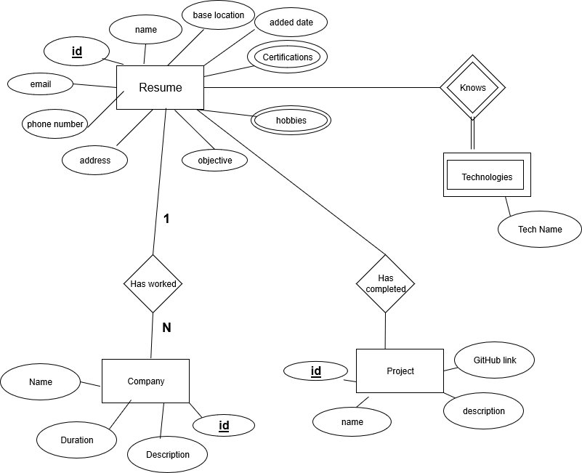

**Intially**:

Resume(**id** , name, email, phone, address, location, objective, hobbies, certifications, added_date, project_name, project_description, github_link, tech_used, company_name, description, duration, knows_tech)

**1NF:**

Resume(**id** , name, email, phone, address, location, objective, added_date, project_name, project_description, github_link, tech_used, company_name, description, duration)

Technology(**resume_id, tech_name**)

Hobbies(**resume_id, hobbie**)

Certifications(**resume_id, certificate**)

**2NF**:

Resume(**id** , name, email, phone, address, location, objective, added_date, project_name, project_description, github_link, tech_used, company_name, description, duration)

Technology(**resume_id, tech_name**)

Hobbies(**resume_id, hobbie**)

Certifications(**resume_id, certificate**)

**3NF:**

Resume(**id** , name, email, phone, address, location, objective, added_date)

Technology(**resume_id, tech_name**)

Hobbies(**resume_id, hobbie**)

Certifications(**resume_id, certificate**)

Project(**resume_id, project_name**, project_description, github_link, tech_used)

Work_Description(**resume_id, company_name**, description, duration)